Solid Edge Fidget Spinner Steps - 01

Before Tutorial
Select the following link to install the free Siemens Solid Edge 3D CAD software for your classroom (www.siemens.com/plm/solid-edge-highschool). Students can download and install their own free copy of Siemens Solid Edge. (www.siemens.com/plm/solid-edge-student).
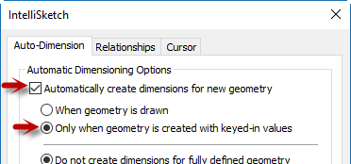
- Start by creating a NEW part file using a Metric Part template.
  - Before we start, navigate to the Sketching Tab and locate
the IntelliSketch options.
  - Open the dialog and set auto-dimensioning as shown.
  - Click OK to dismiss the dialog.
- Draw a Ø 40 mm circle on the Top plane (x,y plane) with its center at the origin point of the base coordinate system.
- Draw a second circle Ø 30 mm above the first and be sure their centers are aligned vertically.
- Draw a Tangent Arc starting at about the 5 o’clock position on the upper circle, Set the radius to 20 mm, and conclude tangent and connected to the bottom circle.
- Mirror the arc to the other side about the Y vector.
- Use the 3 regions to symmetrically extrude 7.50 mm.
Hint: Tap the shift key to toggle symmetry.
- Draw a Ø 25 mm circle on the top face of the model that is centered on the larger lower cylinder.
  - Extrdue the region to subtract a hole.
- Use the Hole command to create a General Screw Clearance for an M8 screw on center with the smaller top cylinder.
Add a Smart dimension between the holes.
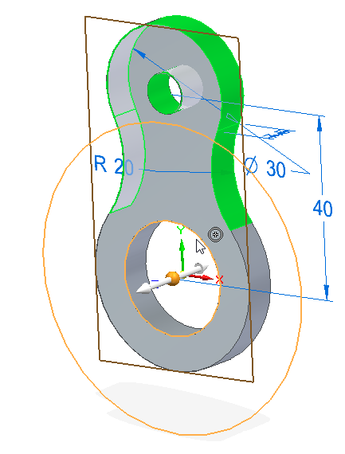
  - With your mouse hovering over the value dimension, scroll the middle mouse wheel and watch the geometry dynamically adjust.
  - Make the value 40.00 mm

- Fence select the upper cylinder, clearance hole, and tangent arc
faces and select the Circular Pattern option.
  - Locate the pattern origin at the center of the
larger bottom cylinder and set the count to 3.
- Select the hole in the original upper cylinder and synchronously drag
toward the center of the part.
  - Ultimately adjust the 40 mm dimension to 34 mm.
- Add 1.00 mm rounds (Face select option) to the top and bottom faces.
- Assign material by double clicking on the Material entry in the PathFinder and setting it to Non-metal, Plastics, and pick ABS Plastic high impact.
- There is no current Lime green face style, so select Styles from the View tab
  - Pick Face Styles from the Style type
  - Select Green from the Styles
  - Click the New button to create a new “Lime Green” style based on the default Green.
    - On the Faces tab
      - Click on the Diffuse color drag the H: value to .26 and the I: value to about .83.
      - Click on the Ambient color and set H: to .26 and the I: value to .57
      - Click on the Specular color and simply set H: to .26
    - Click on the Edges tab and select the option to “Copy from Faces Diffuse Color”
      - Drag the I: slider to about .35
- From the View tab, select Part Painter
  - Set the Style to the new Lime Green
  - Set the selection option to Body
  - Select the part to make it Lime Green.
- From the Application button, select Info and then File Properties.
  - On the Summary tab fill in the Title, Subject, Manager and Company.
  - On the Project tab, fill in the Document Number, Revision Number and Project Name
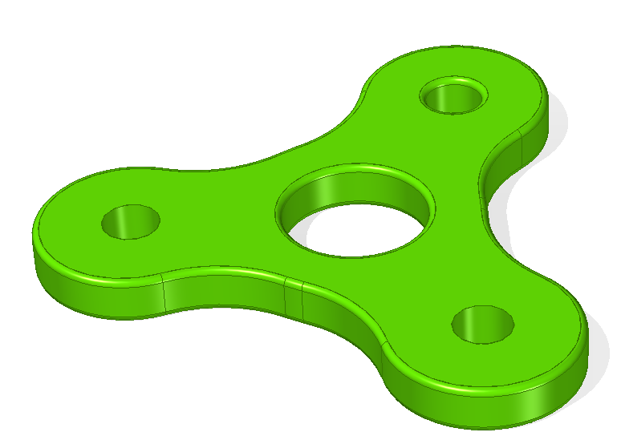
- Save as “Spinner.par” to the Fidget Spinner folder.

