F1 in Schools Tutorial Script – 01 Body

- Start your design using the F1 Model Block and the Virtual Cargo body template.
(F1inSchools_Blank-Cargo.par)
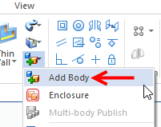
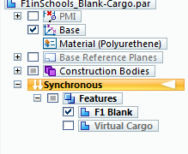
  - Uncheck the feature in PathFinder to hide the Virtual Cargo body.

- Add a new body to create actual Car Body design.
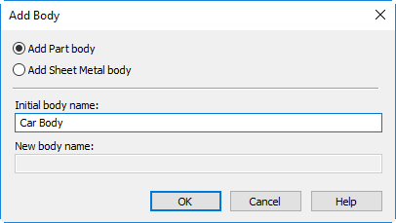
  - Add Part body and name it “Car Body”.
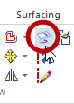
- Click on the Project to Sketch command.
  - Using the orientation cube in the lower right corner,
click on the Right view.
  - Press F3 to lock to the Right plane.
  - Select the bottom edge of the F1 blank to project
to the plane.
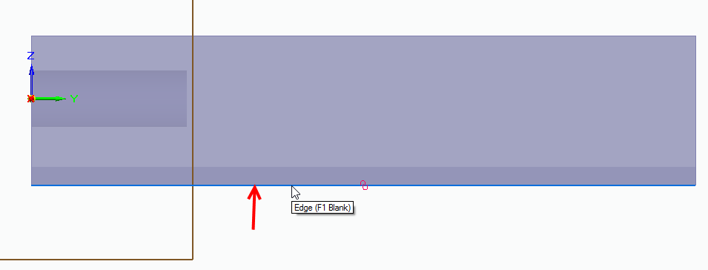

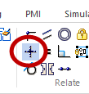

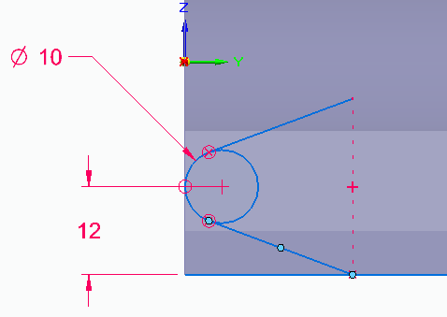
- Draw a 10 mm diameter circle tangent to the left edge of the F1 blank
and 12 mm from the bottom edge.
- Add angled lines tangent to the circle on the top and bottom as shown.
  - Add a vertical alignment between their endpoints.
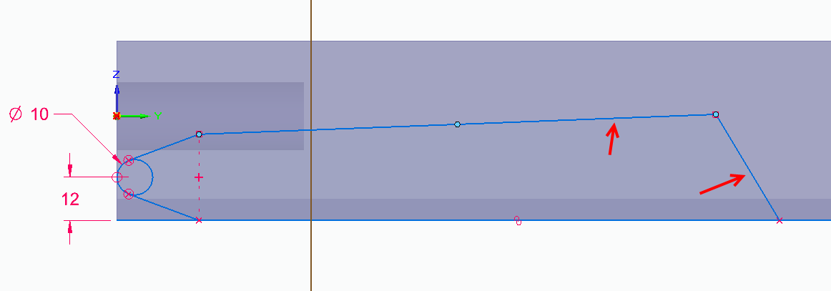
- Sketch 2 more lines approximately as shown.
- Add dimensions using the Smart dimensioning tools to get the desired shape and size.
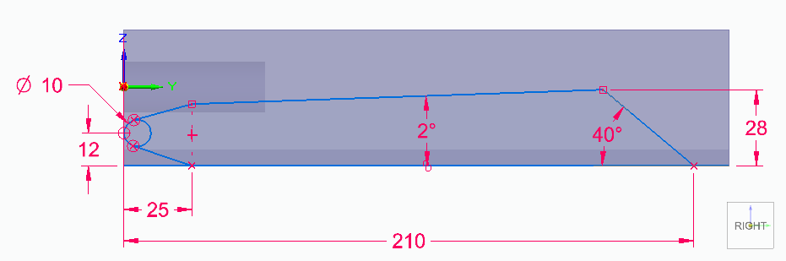

- Press CTL+I to orient to an isometric view.
- Select the closed regions formed by the sketches and begin to drag into 3D.
  - Press the Shift key to toggle on symmetry to drag in both directions.
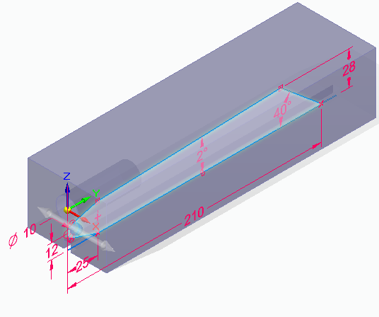
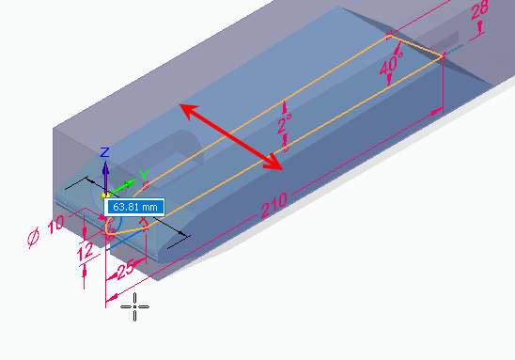
  - Drag the 3D body 64 mm.

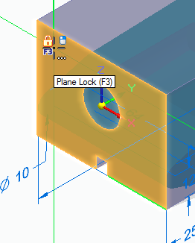

- Select the circle command and use F3 to lock to the
end face of the stock body with the hole.
  - Sketch a 32 mm diameter circle concentric with the hole in the
stock body (This is also the origin of the base coordinate system).
- Sketch 2 lines tangent to circle and extending vertically to silhouette
edge of the end cylindrical face of the first extrusion.
  - Touch the edge arc of the extrusion to align to the silhouette point.
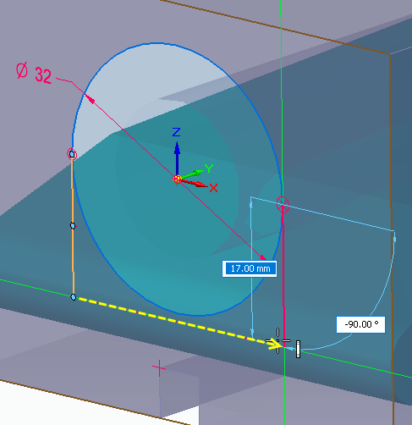
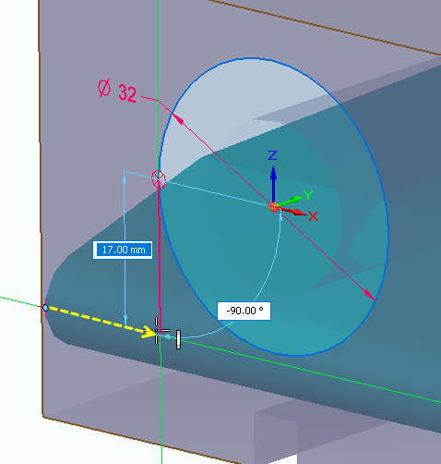
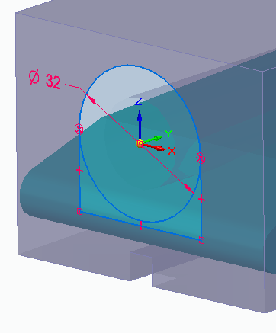
  - Close the sketch.

- Uncheck the F1 blank feature to hide the stock body
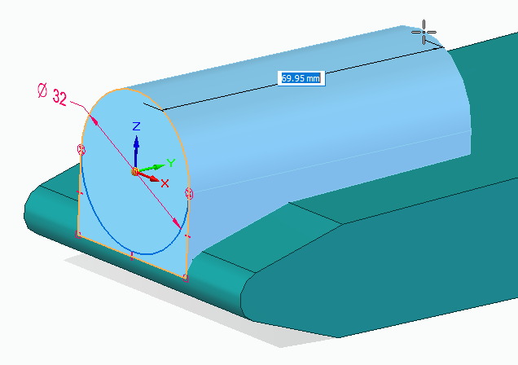
- Select both regions formed by the sketches extrude
into the body 70 mm.
  - Use the Shift key to toggle symmetry off and
the Space Bar to toggle Adding material.

- Turn on the display of the F1 Blank feature.
- Using the Project to Sketch command again, lock
to the end face of the F1 Blank.
  - Select the circular edge of the bore in the F1 blank.
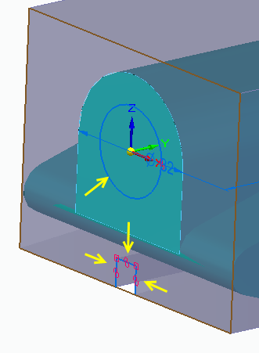
  - Select 3 edge of the slot.

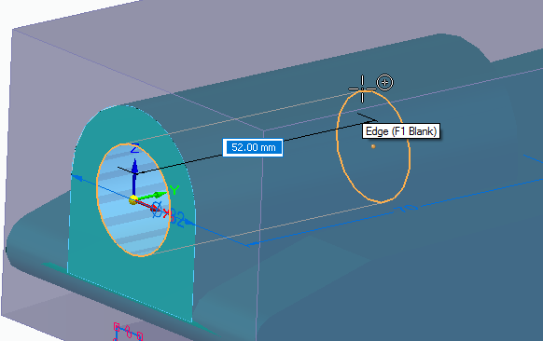
- Use the region of the circle to cut a hole in the Car Body
that is 52 mm deep.
- Hide the stock body and rotate the model so you are looking at the bottom of the part.
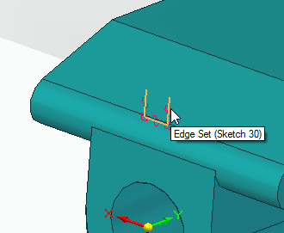
- Select the extrude command and change the selection option
to chain in the command bar.
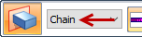
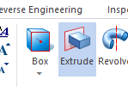
  - Select one line from the slot profile to chain will
select all 3 lines.
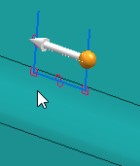
  - Right click to accept the selection and then move your cursor to
point the arrow to the inside of the U-shape as the side of the open
profile to remove and click to set this option.
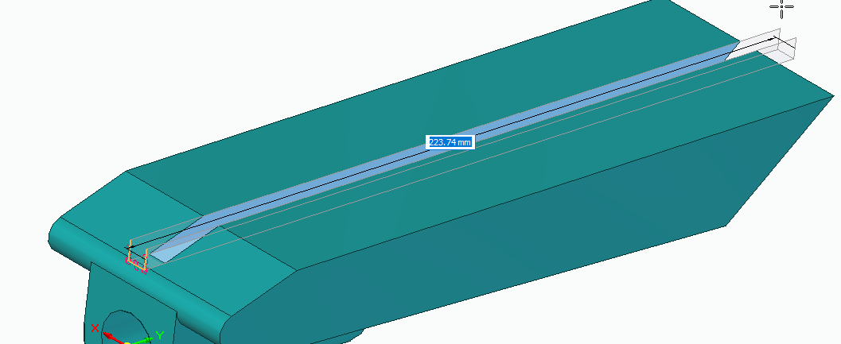
  - Press the spacebar to toggle removing material and drag the
profile completely through the part and finish the cutout.

- Next we want to create a lofted extrude to add aerodynamic features to the car.
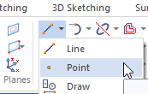
  - Select the Point command and lock to the
top face of the car body using F3.
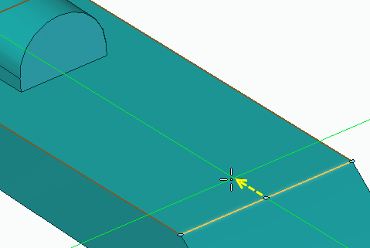
  - Touch the right edge of the locked face to find its midpoint
to align with and click to create a point on the face.
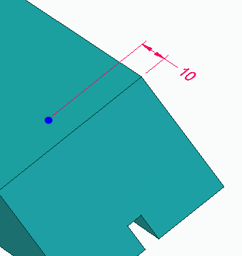
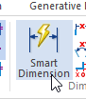
  - Add a Smart dimension to the Point and make it 10 mm
from the edge.

- Select the Loft command.
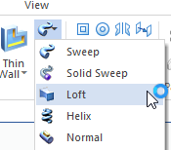
  - Select Face option in dropdown menu to select front face
of cartridge housing.
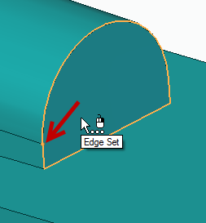
HINT: be sure the point
appears at the end of the tangent line
as indicated by the red arrow.
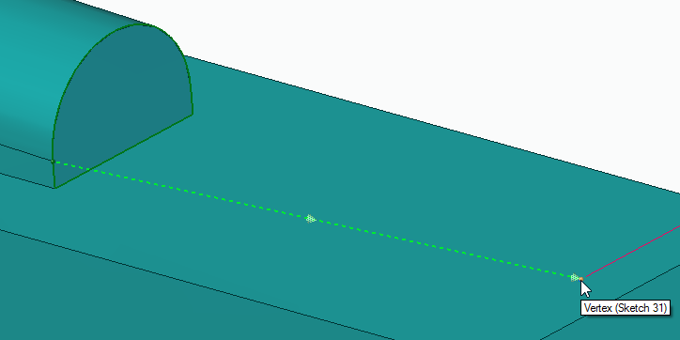
  - Change the selection option to Point from dropdown and select the sketch point.
  - Click the Preview in the command bar or right mouse click to preview the Loft.
  - From the tangency control drop down, select Tangent Continuous.
    - Set to 1.500
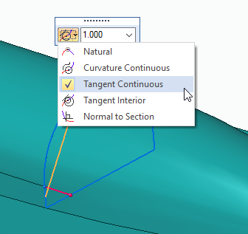
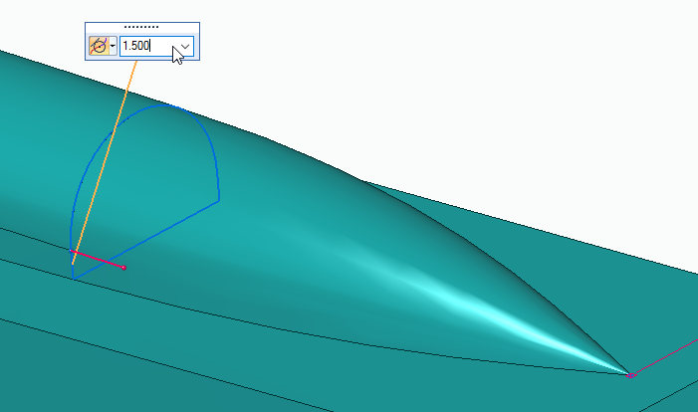
  - Click Finish.

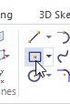
- Rotate the model to see the bottom face (slot side).
- Select the Rectangle by Center command and lock to the bottom face of the car body using F3.
  - Select “Bottom” on the view orientation cube in the lower right.
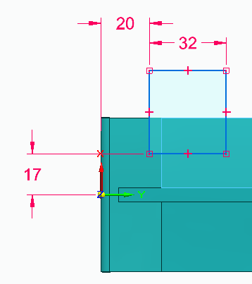
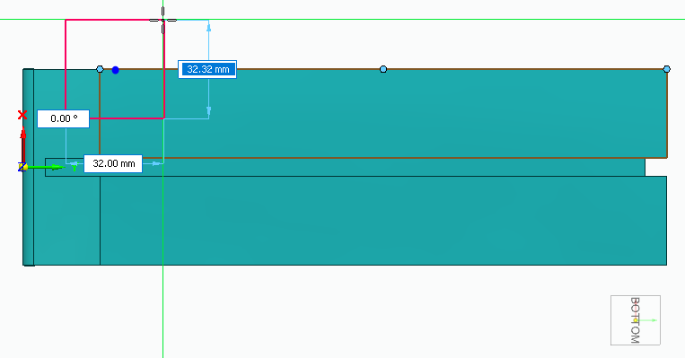
- Sketch a rectangle centered on the edge of the body.
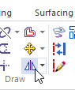
- Add dimensions to size and
locate the rectangle.
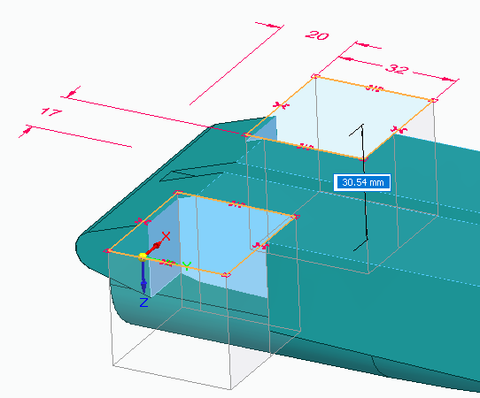
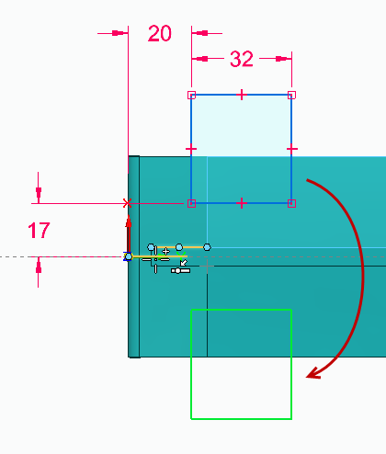
- Mirror the rectangle about
the Y axis.
- Use the regions created by the rectangles to cut
wheel well slots in the car body.

- Select the wheel well cutout features from the PathFinder (last Cutout feature).
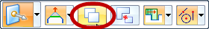
  - In the command bar select the option to move with copy.
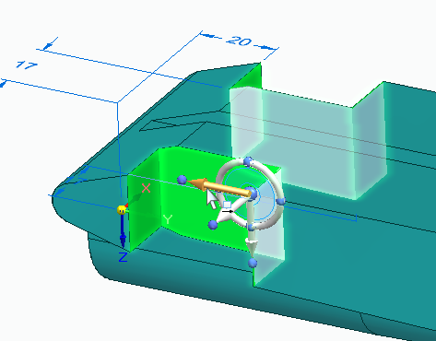
  - Select the arrow on the steering wheel to initiate a synchronous copy/move.
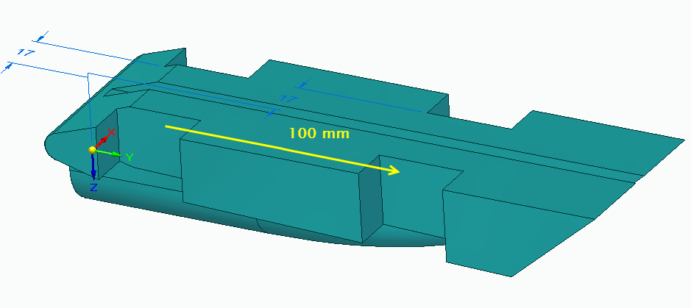
  - Copy the cutout 100 mm to the front of the car body.
- Select the front face of the last cutout and select the arrow to start a synchronous edit.
  - NOTE: symmetry automatically selects the face on the opposite side.
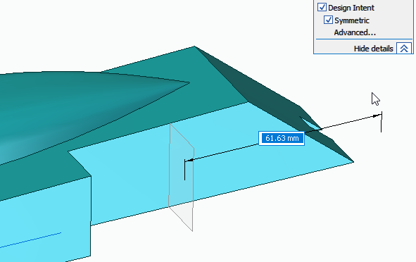
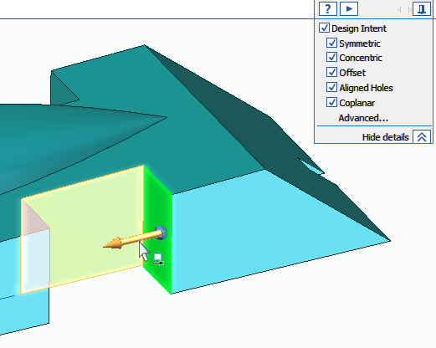
  - Drag through the end of the part.

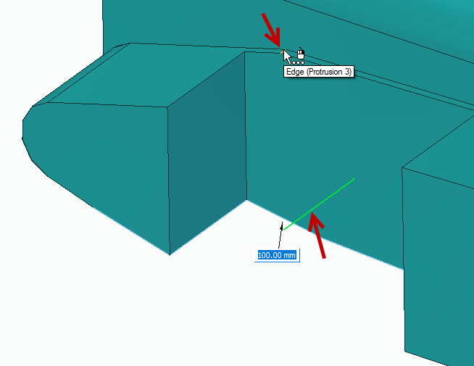
- Add 100 mm radius rounds on the top and bottom edges between the top face of the body and the rear angled faces.
  - Add to both sides of the car

- Select the Circle command and lock to the inside face
of the rear wheel well.
  - Select the Right orientation using the view cube.
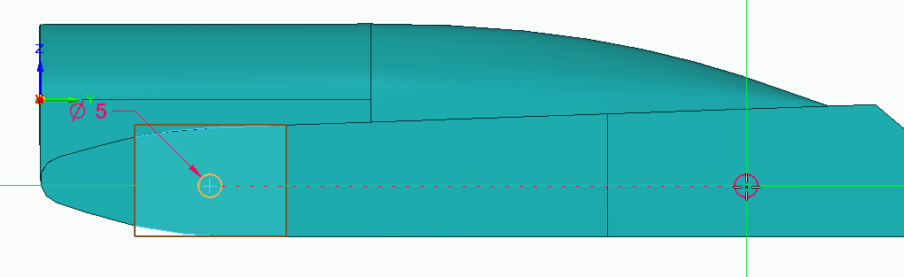
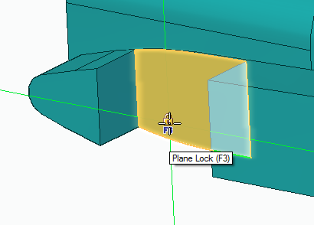
  - Sketch two 5 mm diameter circles approximately as shown; be
sure that they are in horizontally aligned.
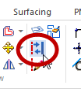
  - Add concentric 26 mm circles to represent the size of the wheels and set these 2 circles to construction.
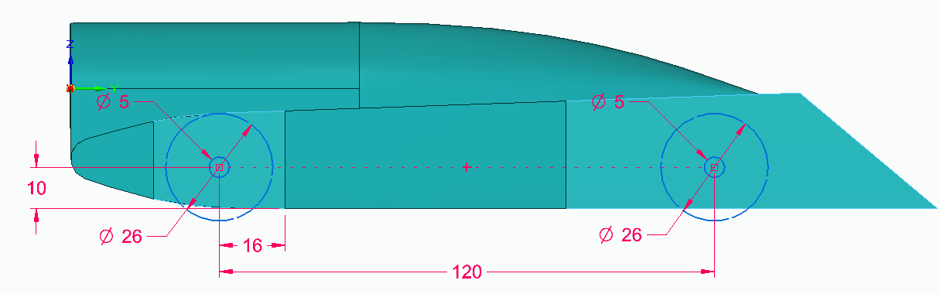
- Add dimensions shown to fine tune their locations.
- Add holes for wheels using extrude cut
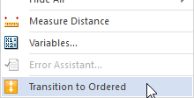
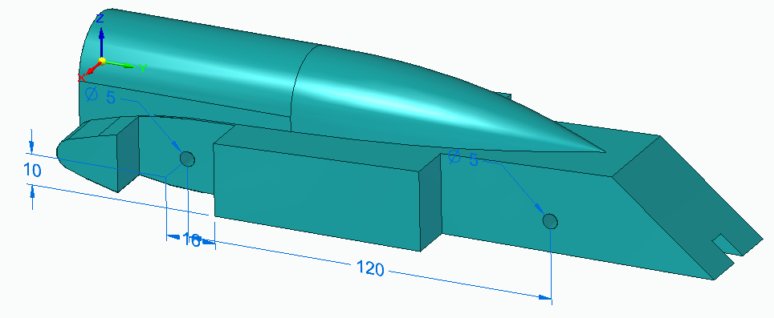
  - Using the regions created by the inner circles, drag holes completely through the part.
- Right click in the graphics window to bring up the
shortcut menu and select the option to
Transitioned to Ordered at the bottom of the menu.
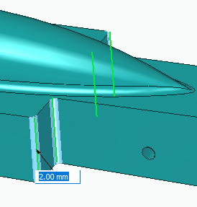
- Add rounds to the following area:
  - Add 3mm rounds along cylindrical cockpit.
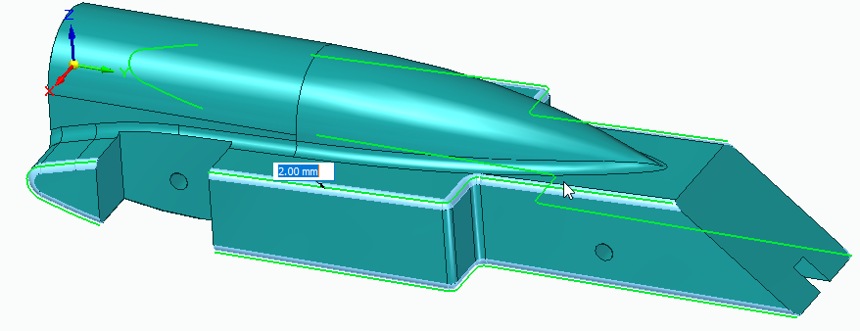
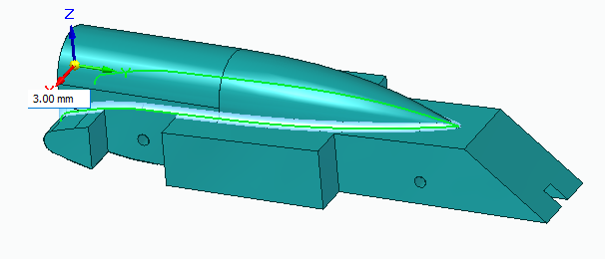
  - Add 2 mm rounds to the front 4 corners of the fuel tank
area and then to the top and bottom edges.
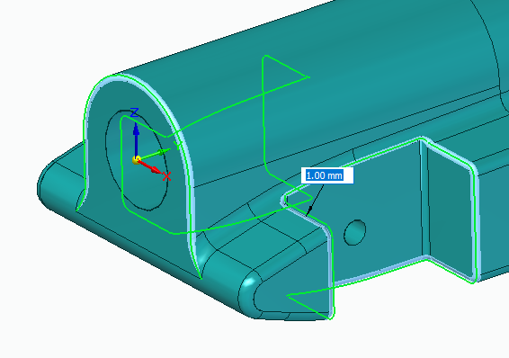
  - Add 1 mm rounds to the rear wheel wells
and back of the cockpit housing.

- Click on the check box next to Virtual Cargo in the Pathfinder to bring the part into view.
  - Select the virtual cargo by clicking on the part or selecting from the pathfinder.
  - Click on the bottom arrow to drag the part downward.
  - Drag the part into the car body such that it is completely inside.
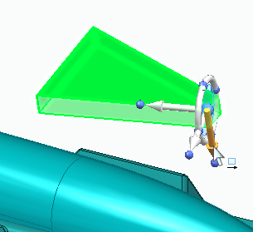
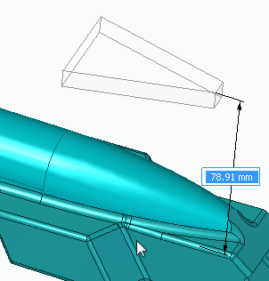
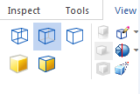
  - Check by switching the view to wired view under the view tab.

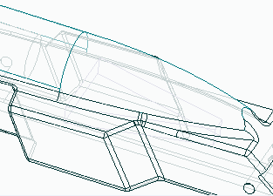

- Return to the normal view and uncheck the virtual cargo from the Pathfinder.
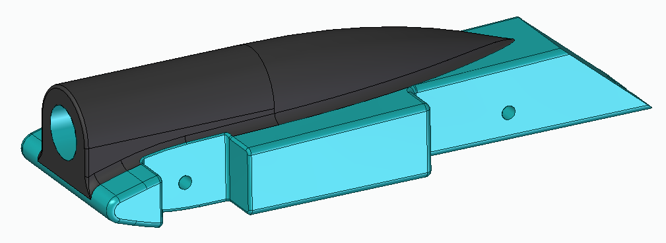
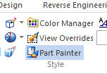
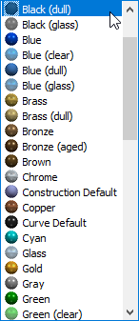
- From the view tab, use Part Painter feature to paint the cockpit
are to your the desired color’.
- Save part with a new name to avoid overwriting original template.

