F1 in Schools Tutorial Script - 02 Front Wing

- Start your front wing design by using the previously made F1 Body design part. (Car_Body.par)
- Create a new assembly.
  - Select “Assembly of Active Model” option
  - Save the new F1 assembly ex. (My_F1_Car_Assembly.asm)
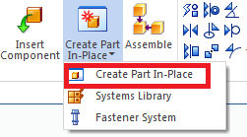
- Create new part in place.
  - Select “Create Part in Place”.
  - Select OK when dialogue box comes up.
  - Select Polyurethane for material in dropdown menu.
  - Click Green checkmark button.
  - Save the part file ex. (front_wing.par)

- Click on the Project to Sketch command.
  - Using the orientation cube in the lower right corner, click on the Right view.
  - Press F3 to lock to the Right plane.
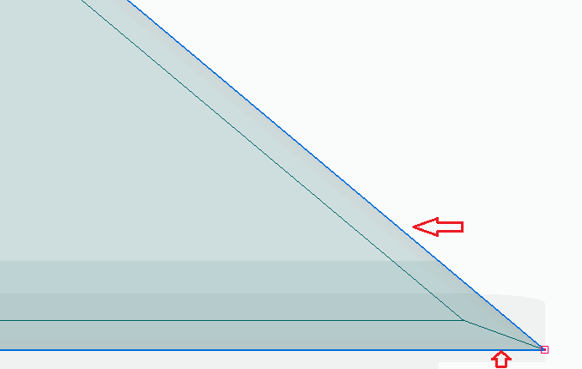
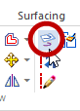
  - Select both front edge and bottom edge of model.
- Click on the offset button to create offset line parallel to front edge.
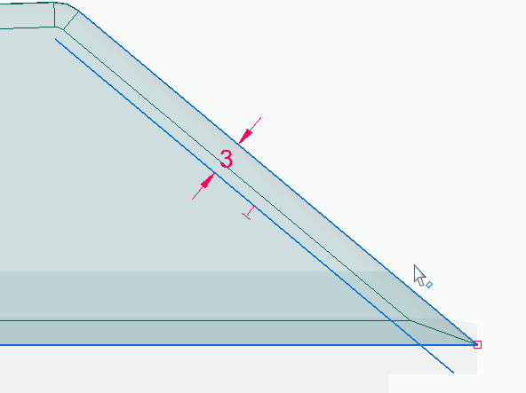
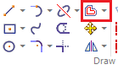
  - Change the distance to 3 mm.
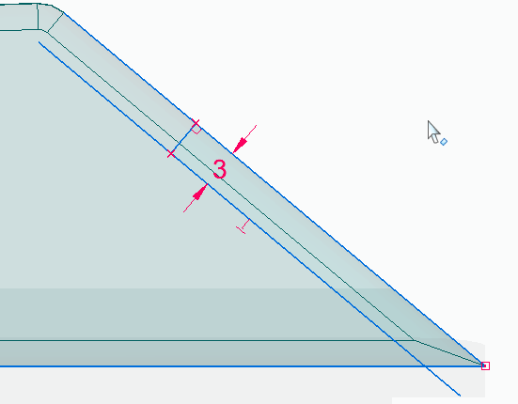
- Create a line perpendicular to
both front edge and offset line.
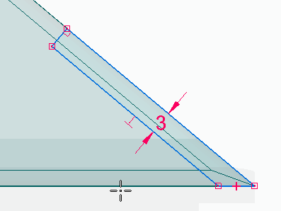
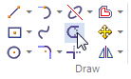
- Select the trim button to trim
the remaining line on the sketch.

- Create angle dimension for the sketch.
  - Set 40° angle between offset line and bottom edge.
  - Lock the angle using the locking button.

- Set vertical distance for the wing using smart dimension.
  - Select horizontal side and angled side to create the dimensions.
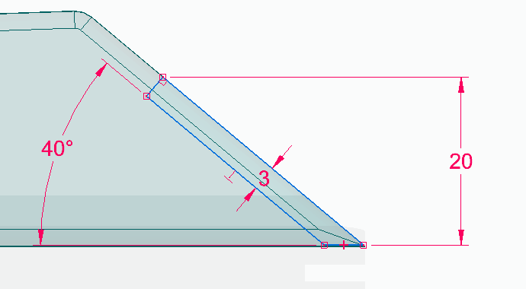
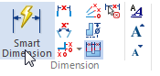
  - Set measurement to 20 mm.
- Click on the region inside the sketch and extrude using the arrow which pops up.
  - Press shift to toggle symmetry.
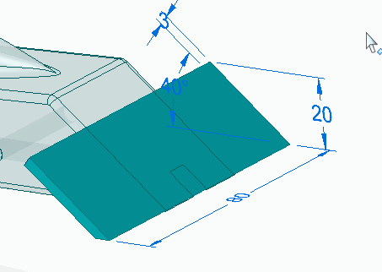
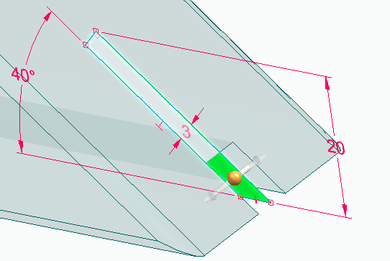
  - Set extrude to 80 mm.

- Click on the line command.
  - Hover the cursor over the end face of the previous extrusion until it highlights.
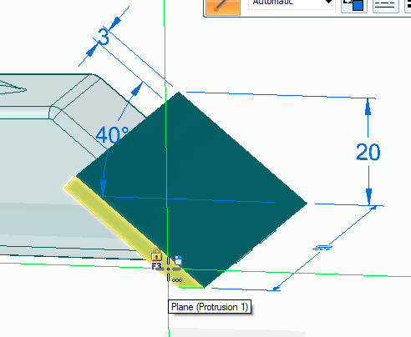
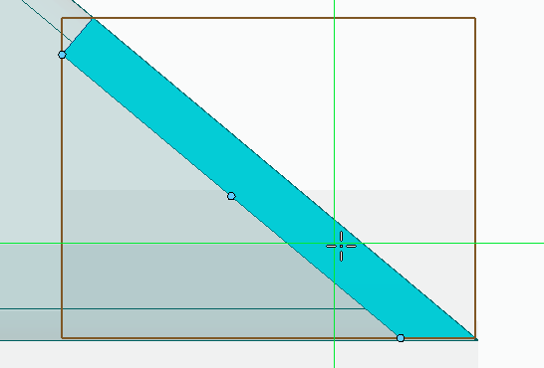
  - Press F3 to lock the plane.
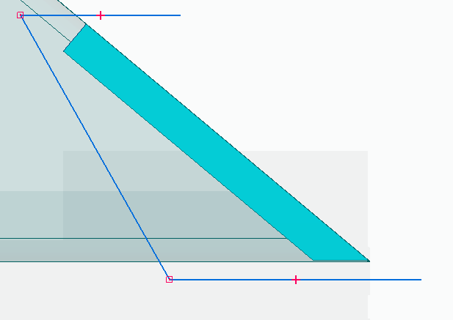
  - Press CTRL+H to orient the view to
the plane

- Sketch 3 lines similar to the ones
shown in picture.
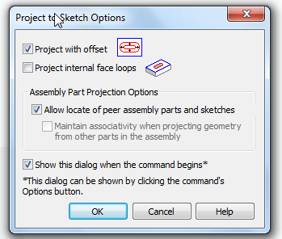
- Create fourth line by offsetting the edge with the wing.
  - Use the Project to Sketch button.
  - Select “Project with offset” option and click OK.
  - Select the edge with the wing and offset by 3 mm.
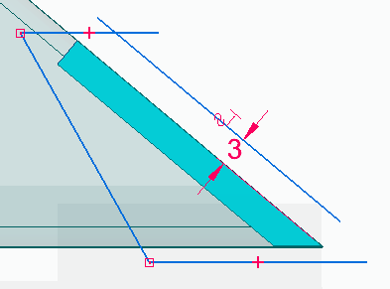
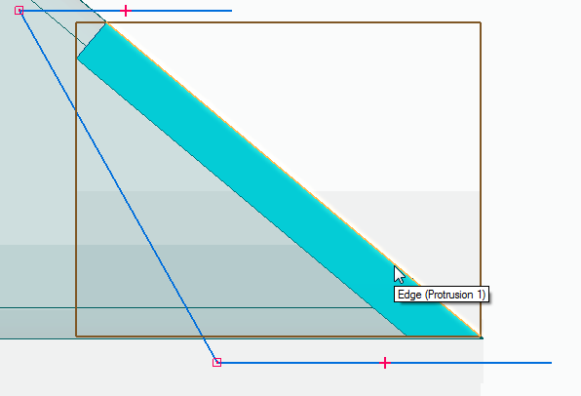
- Use the Trim Corner command to connect the ends of the sketch lines.
  - Click and drag around the corners to remove extra lines or to extend the corners.
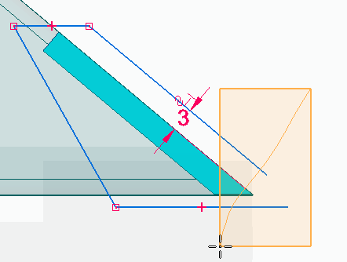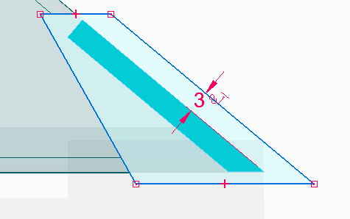
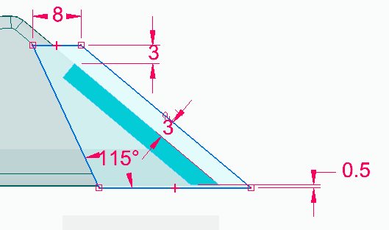
- Using Smart Dimension, add dimension
to the sketch as shown.

- Select both sketch and outer face of wing to extrude.
  - Select the add options in extrude toolbar.
  - Deselect the symmetric option.
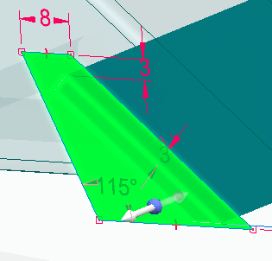
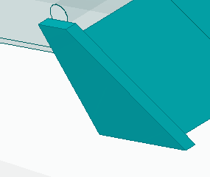
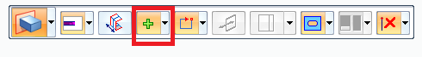
  - Extrude 3 mm into the wing.

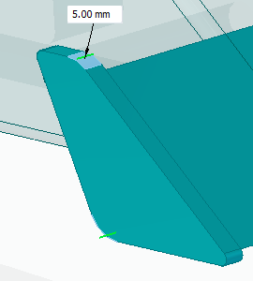
- Add rounds to wing’s outer body.
  - Select the edge/corner option from the dropdown menu.
  - Select the two acute edges and set their radius to 1 mm.
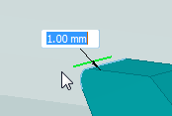
  - Select the two obtuse edges and set their radius to 5 mm.

- Use the Face option from dropdown menu to round entire end face.
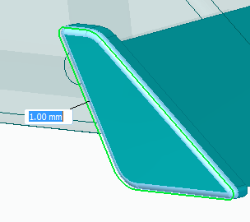
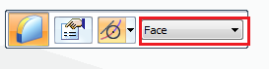
  - Set radius to 1 mm.

- Use mirror option to copy the outer body on one side of the wing to the other side.
  - Select the entire outer feature by clicking and dragging
a box around the geometry.
  - Select the Mirror button.
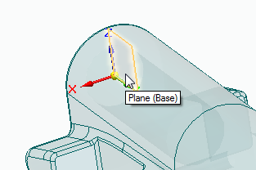
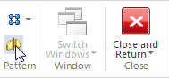
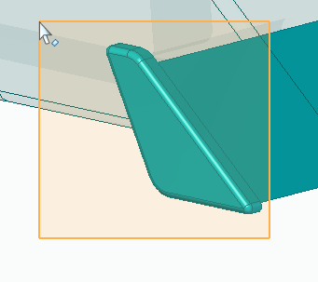
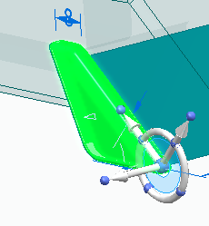
  - Select the right plane using the coordinate system.
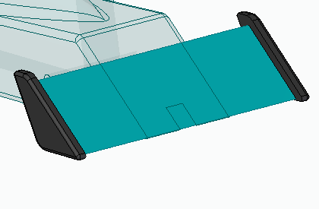
- Use the Part Painter on the View tab to color
the wing support structure Black (dull).
  - Click and drag around the structure.

- Create a projection of the slot in the bottom of the car body.
  - Select project to sketch button.
  - Lock to the XZ plane from the coordinate system.
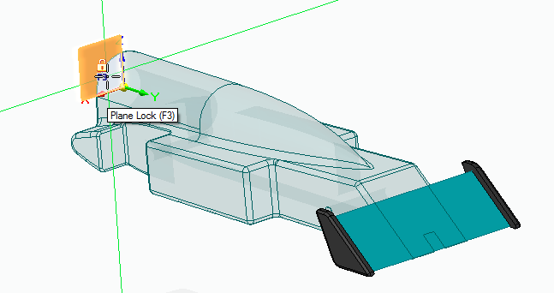
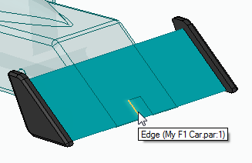
  - Select the 3 edges of the slot in the front of the car body.

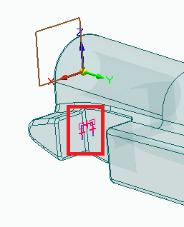
- Add slot in the wing by removing material.
  - Click on the Extrude command.
  - Select chain option from dropdown menu.
  - Select the 3 projected edges on the XZ plane with one click.
  - Select the cut option from dropdown menu.
  - Point the arrow to the inside of the slot shape and click.
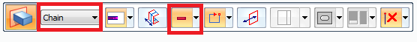
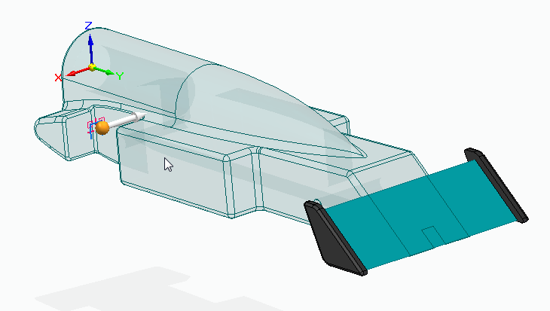
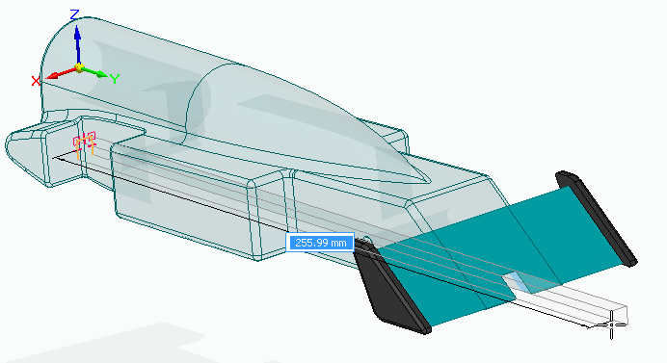
  - Drag the cut through the front wing.

- Isolate the wing by hiding the rest of the body by pressing CTL+Q.
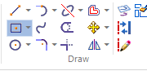
- Add a “Rectangle by center” to the top thickness face of wing.
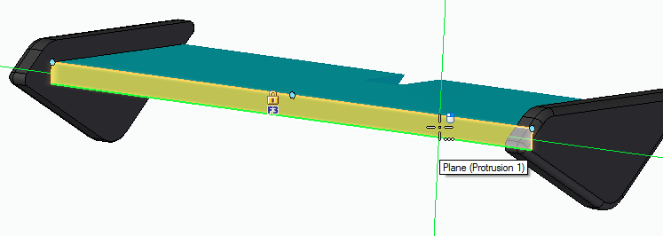
  - Define the center of the rectangle to be on the
midpoint of the edge of the face.
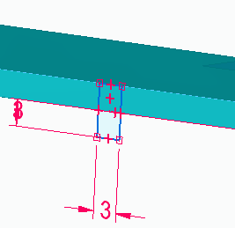
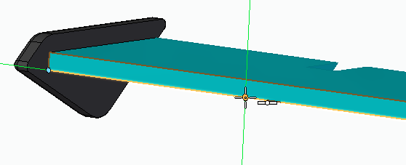
  - Add dimensions to the drawing as shown.
- Click on the region defined by the sketch and select arrow to extrude 10 mm towards the slot.

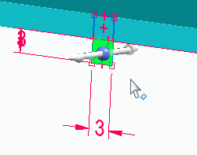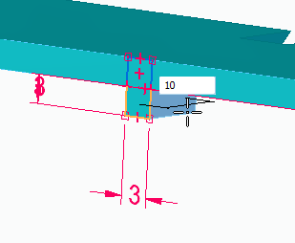
- Show the Car Body (CTRL+Q) and notice how the wing interferes with the body.
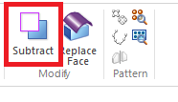
  - Click on the Subtract command on the Features tab.
    - Select the Body as the target for the subtraction.
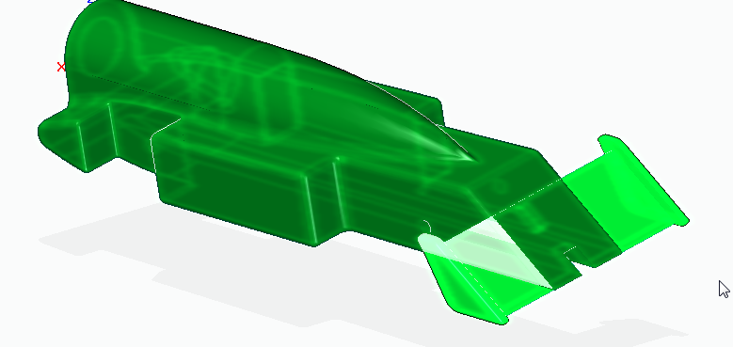
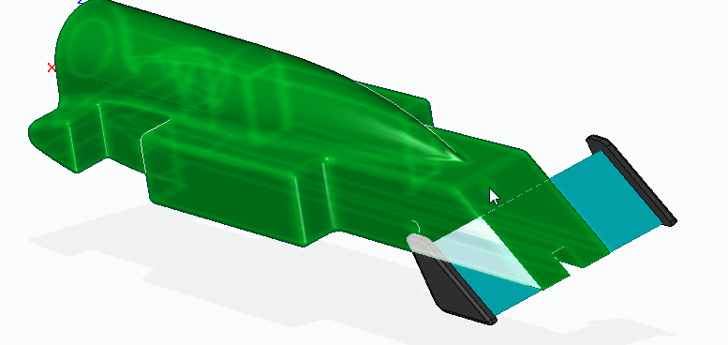
    - Select the Front Wing as the tool body.

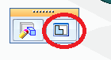
- In place activate into the car body by clicking the Edit in place button
after selecting the body, and notice the new pockets in the car body
for the Front Wing.

- Select the bottom face of the Front wing key slot.
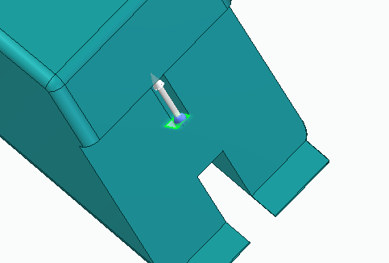
  - Remove the material by dragging the face downward through the bottom slot.

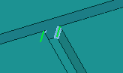
- Add Rounds to the edge of the extrusion.
  - Use the edge/corner option from dropdown menu.
  - Add 0.5 mm rounds to the edges.

- Add round to the front of the car body.
  - Use the chain option from dropdown menu.
  - Type in radius of 1 mm.
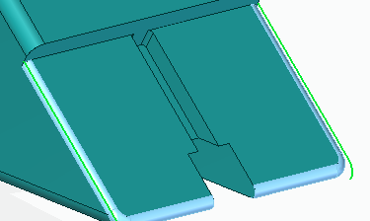
  - Select the edge of the front face of the car body.
- Close and return to the assembly.

- Isolate the Front Wing by selecting it and clicking on the Edit in place icon.
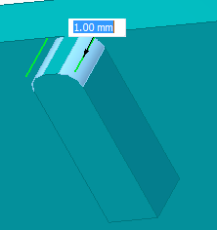
- Click the Round command and select the top edges of the feature.
  - Add 1 mm rounds.

- Click arrow underneath round button for more options.
  - Select Chamfer Equal Setbacks option.
  - Select the edge of the extrusion.
  - Set the setback distance to 0.5mm.
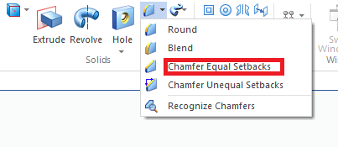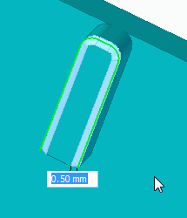
- Finally round the bottom front edge of the wing using the round button.
  - Set round to 1mm.
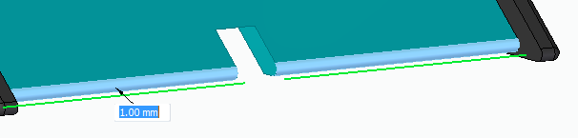
- Select Close and Return to go back to the top level assembly.
- Save the assembly.

- You have now completed the Front Wing of the F1 Car.
