F1 in Schools Tutorial Script - 03 Rear Wing

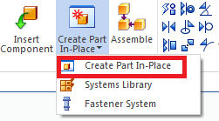
- Start your rear wing design by using the previously made F1 Body design assembly. (My_F1_Car_Assembly.asm)
- Create new part in place.
  - Select “Create Part in Place”
  - Select OK when dialogue box comes up.
  - Select Polyurethane for material in dropdown menu.
  - Click on the Green checkmark button.
  - Save the part file ex. (rear_wing.par)

- Orient the model in order to sketch on the correct plane.
  - Using the orientation cube in the lower right corner, click on the Right view.
  - Press F3 to lock to the Right plane.
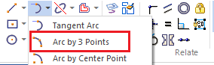
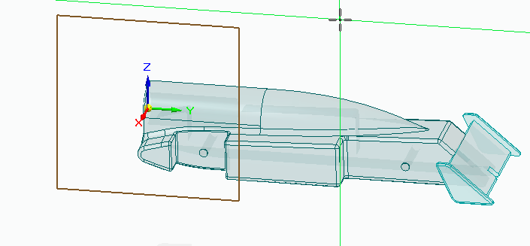
- Click on the arc button and select “Arc by 3 Points”.

- Draw an arc using 3 points above the car body.
  - This is an estimation and correct dimension will be applied later.
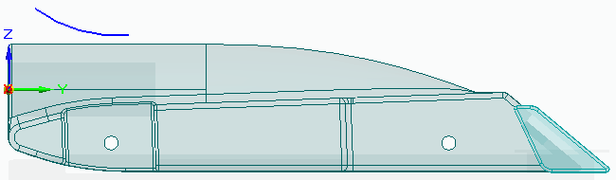
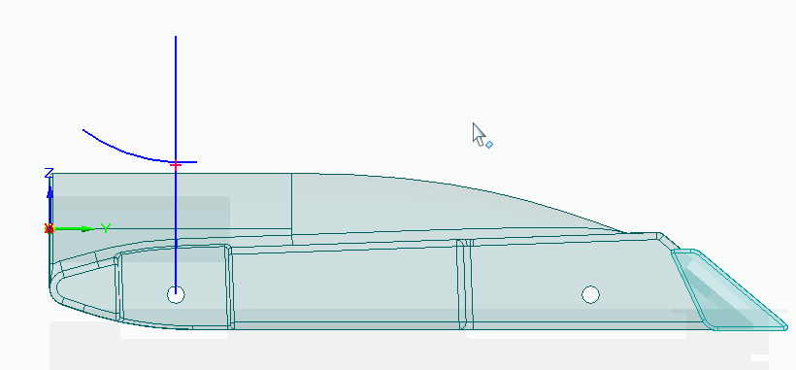
- Using the line sketch feature, draw a line starting from the centerline of the rear wheel axle upwards.

- Click on the connect button in Relate section to align the arc center to the vertical line.
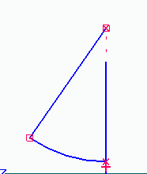
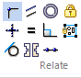
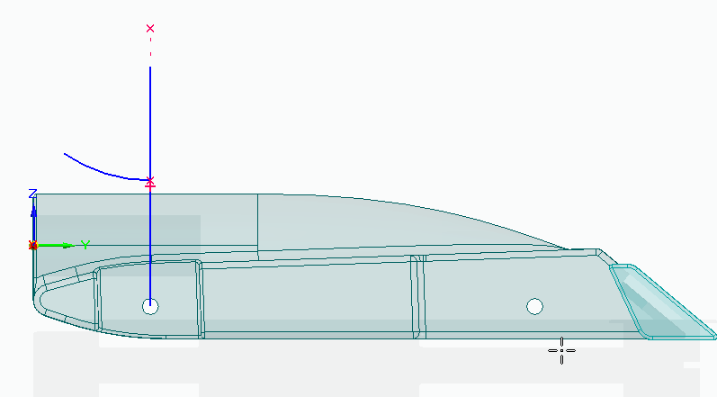
- Using the same connect button, connect the arc and the centerline to remove the remaining arc segments.

- Draw another line from the arc centerline to the other end of the arc.

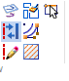
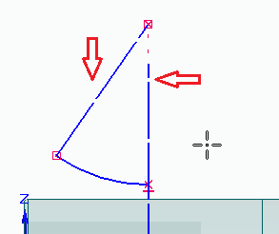
- Click on the construction button and select both straight lines.
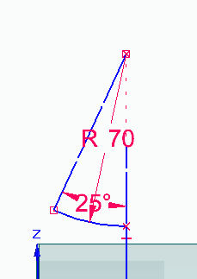
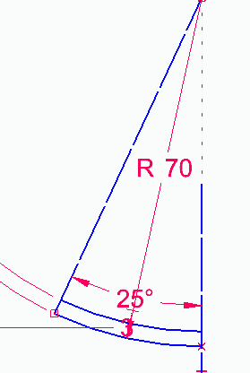
- Using the smart dimensions, define the radius of the arc 70mm.

- Define the angle of the arc 25 degrees.

- To define the thickness of rear wing:
  - Offset the arc by clicking on the offset button and selecting the arc.
  - Offset the arc to the inside 3 mm.

- Sketch an angled line from the lower endpoint of the arc
  - Line should be at a 135° angle as shown.
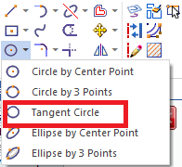
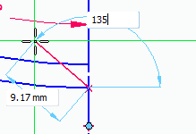
  - Press the tab key to enter the angle dimensions instead of length.

- Sketch a circle on the trailing edge to create the back end of the wing.
  - Select the tangent circle option from the dropdown menu.
  - Place the circle between the two arcs.
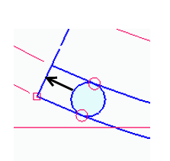
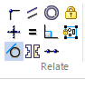
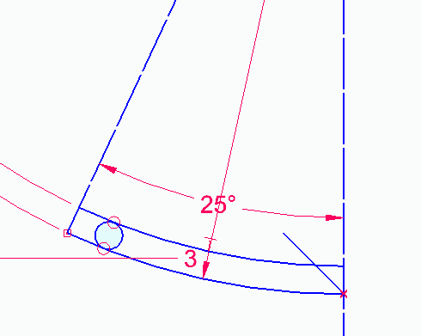
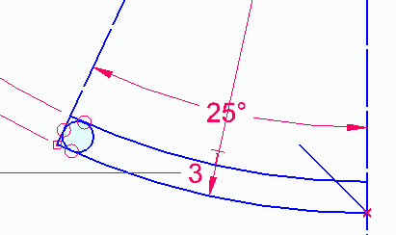
  - Apply a third tangent relationship between the arc and
the angled line as shown.

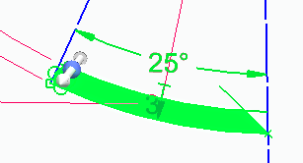
- Taking advantage of the synchronous technology,
click and drag a box around the sketch
to select the enclosed shape.
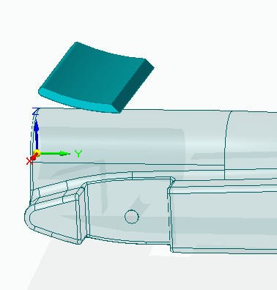
- Extrude the enclosed shape 80 mm.
  - Press shift to toggle symmetry.
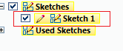

- Since we no longer need the sketch,
we can delete the sketch in the pathfinder.
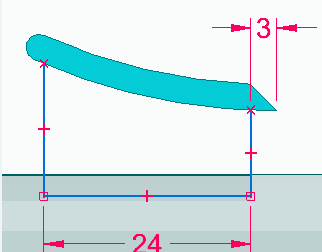
- Sketch 3 lines on the center plane to create the
mounting structure for the rear wing.
  - Using the smart dimensions, add a few
dimensions to the sketch.

- Use the extrude feature to create a solid extrusion.
  - Extrude the structure 20 mm symmetrically.
  - Make sure to select chain option from the dropdown menu.
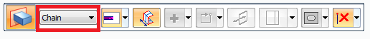
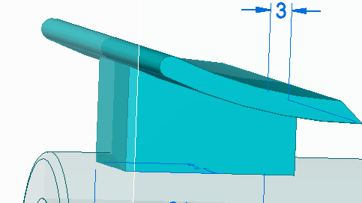
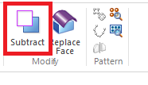
- Use the subtract feature to subtract the wing from the car body.
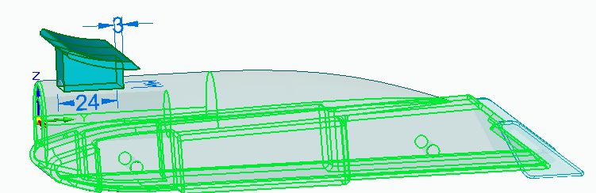
- Add rounds to the model to make it aesthetically pleasing.
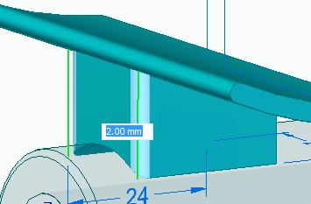
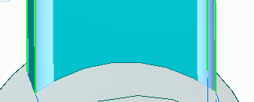
  - Round the 4 corners on the support structure.
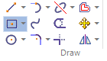
- Sketch a rectangle by center on the back side of the wing.
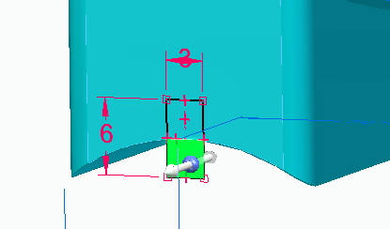
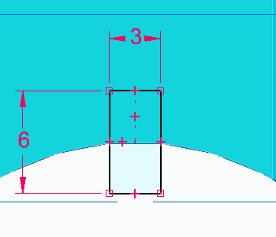
  - Dimension the rectangle 3 mm wide and 6 mm height.

- Extrude the lower region of the rectangle.
  - Extrude 22 mm towards the leading edge of the wing.
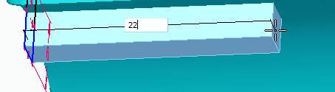

- Using the Pathfinder, delete the rectangle sketch.
- Use the coincident plane feature to create a plane coincident to the side of the mounting structure.
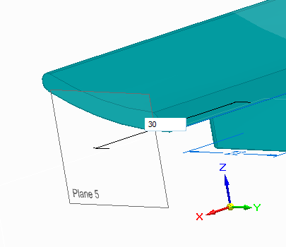
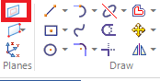
  - Using the steering wheel, translate the plane so that it is coincident to the end face of the wing.

- Use the new sketch plane to create a sketch for the support structure at the end of the wing.
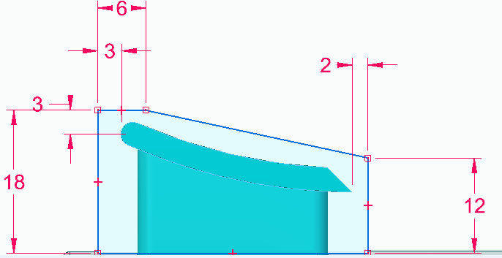
  - Use smart dimensions to add a few measurements to the sketch.
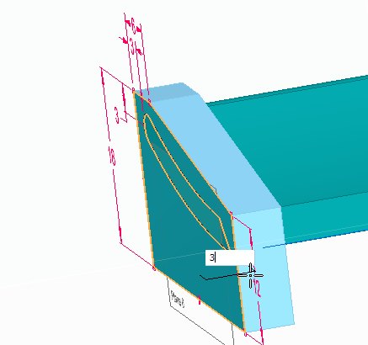
- Select the sketch and the wing arc to
extrude 3mm towards the center plane.

- Add rounds to the 4 corners of the structure for aesthetic purposes.
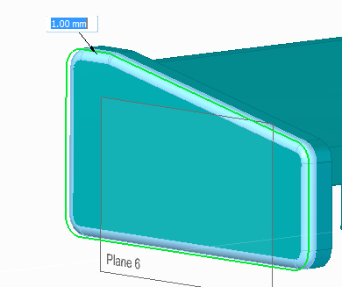
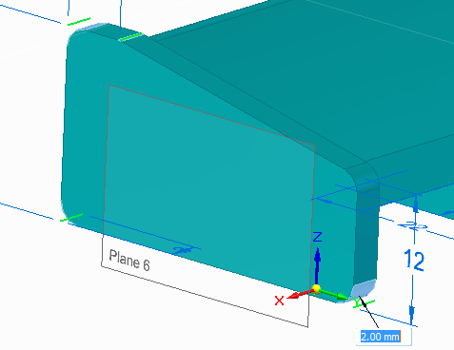
  - Select face round option in the drop down menu to add round to the entire face of the support structure.

- Click and drag a box around the entire support structure to select it.
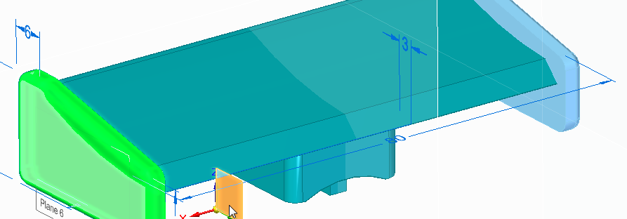
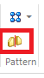
  - Mirror the entire structure across the center plane using the mirror feature command.

- Use part painter feature to paint the two end structures of the wing.
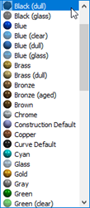
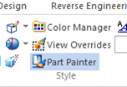
  - Paint the structures Black (dull).

- Click on the “Close and Return” button to close and return to the top level assembly.
- Use the subtract feature to subtract the rear wing body from the
car body to remove the interference

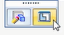
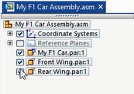
- Uncheck the box next to rear wing part in the pathfinder so
that you can see the slot in the car body.
- Click on the car body and select edit in place
  - Extend the resulting slot by dragging
the end face beyond the edge of the part
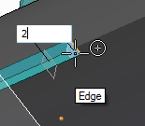
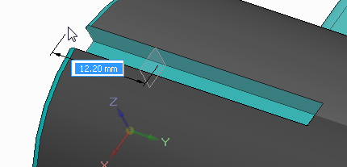
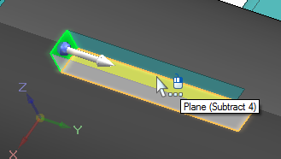
  - Also drag the front end of the slot an extra 2 mm.
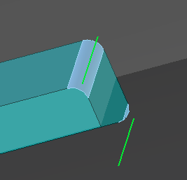
- Add rounds to the corners of the slot using
the Round feature.
  - Specify a 0.5 mm radius for these
rounds.
- Click on “Close and return” button to exit and return to the assembly.
- Check the box next to rear wing part in pathfinder to see the entire assembly.
- Select the rear wing and click Edit in Place option to work with only the wing.
  - Add chamfers to the bottom edge of the key.
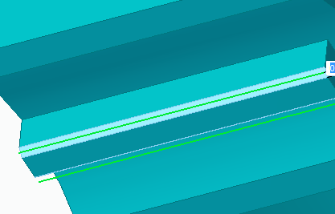
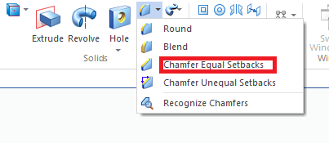
  - Select “Chamfer Equal Setbacks” from the dropdown menu.

- Add 2 mm rounds to the bottom of the wing.
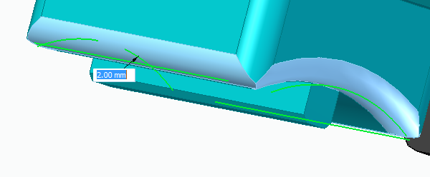
  - Make sure to round all four sides of the wing as shown in the picture below.

- Click on Close and Return button.
- Save the assembly to save the changes to the parts.
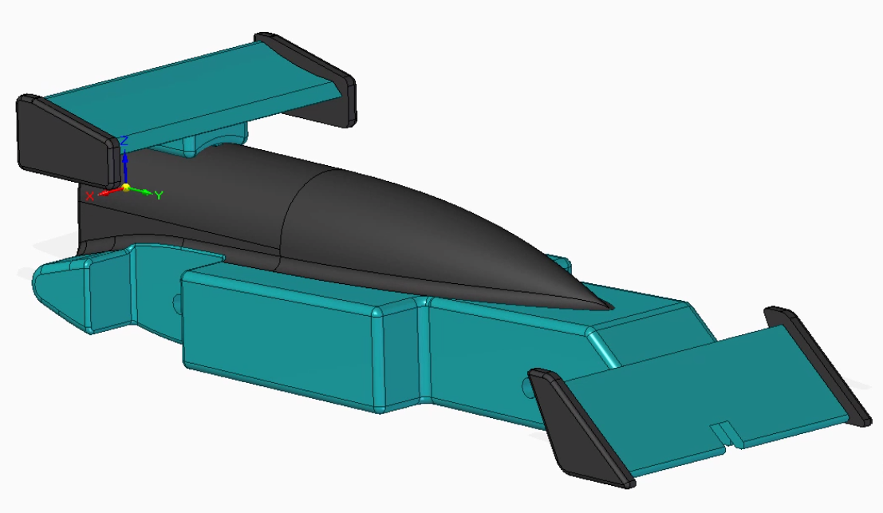
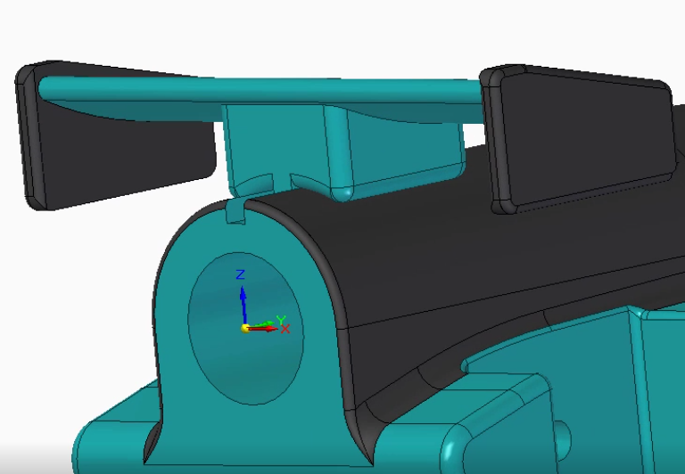
- Now you have completed the rear wing of the F1 Car.

