F1 in Schools Tutorial Script - 04 Assemble

- Start by opening the previously made F1 Body design assembly. (My_F1_Car_Assembly.asm)

- Expand the Parts Library from the fly-out menus.
  - Navigate to the folder ..\F1_in_Schools\_Library

- Click and drag the axle from the library into working space.
  - Align the centerline of the axle to the rear hole in the car body.
  - For cylindrical object, automatic axial alignment is created.
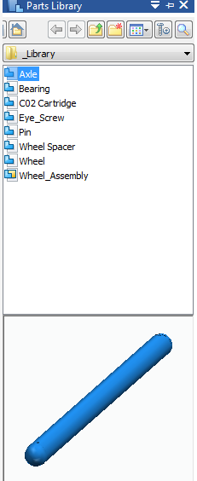
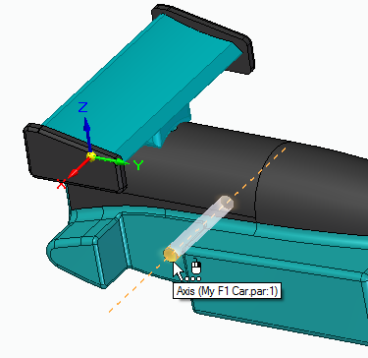
- For the second relationship, select the center plane relationship from the drop down menu.
  - In the Quick bar, be sure the option is set to Double.
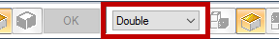
  - Select the two end center points of the axle and
then two side faces of the car body.
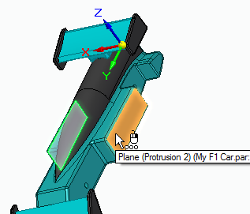
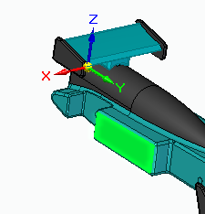
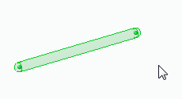
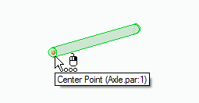
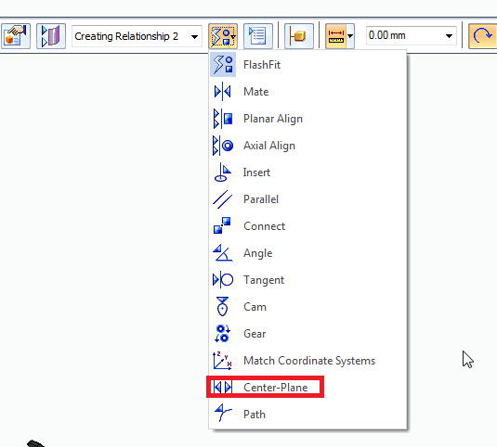
  - Press esc to exit the Assemble command.

- Drag another axle into the working space.
  - You can drag the axle from Parts Library or click and drag from Pathfinder to make another copy of the axle.

- For aligning the front axle, repeat the same steps used for back axle.

- Click and drag the Wheel Spacer from the Parts Library to create space between the wheels and the car body.
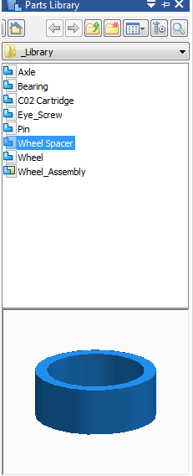
  - Align the centerline of the spacer with the rear axle centerline.
  - Automatic centerline relationship is created by simply clicking on the rear axle.
  - Click on the car body face to create second relationship as shown in the picture.
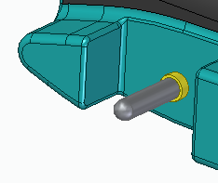
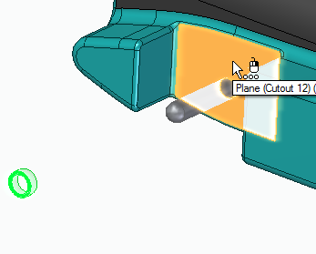
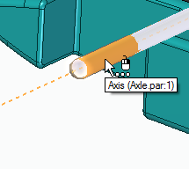
  - Press esc to exit the assembly.

- Click and drag a Wheel Assembly from the Parts Library.
  - For the first relationship, mate the Wheel to the outer edge face of the spacer.
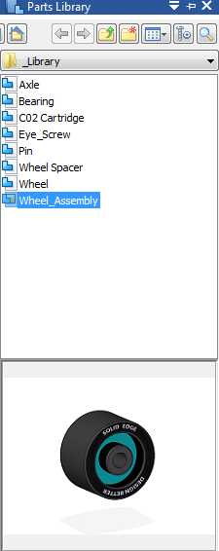
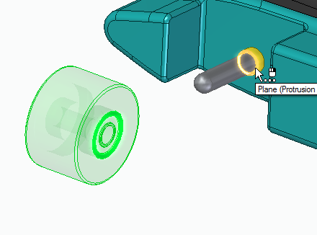
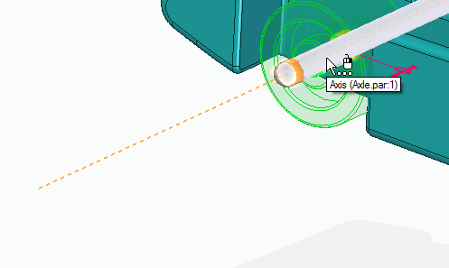
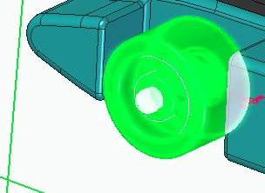
  - For the second relationship, align using the centerline of the spacer.
- Repeat the previous two steps to assemble the remaining three spacers and wheels.

- Click and drag a Pin from the Parts Library.
  - For first relationship, align using the centerline of pin and the hole in the axle
  - For second relationship, select the axle face adjacent to the wheel.
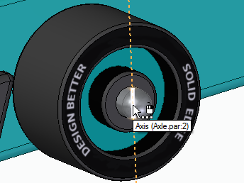
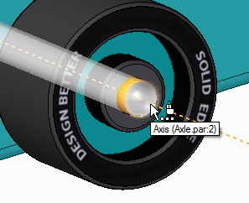
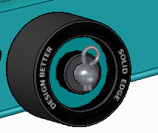
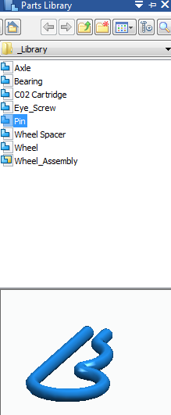
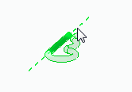
  - Press esc to exit.

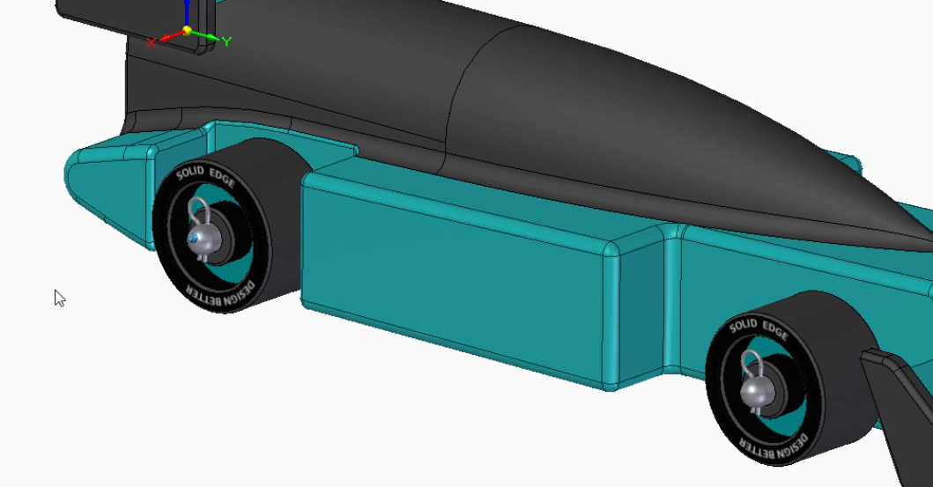
- Repeat the previous step to assemble the remaining three pins.

- Click and drag the CO2 cartridge from the Parts Library.
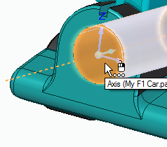
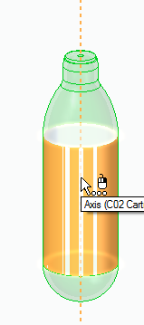
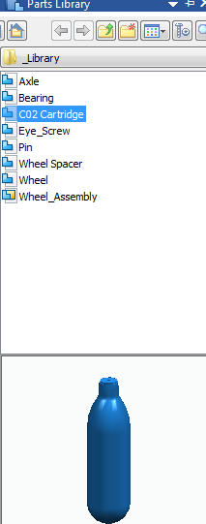
  - For first relationship, align using the centerline of CO2 cartridge and the centerline of the bore hole in the back of the car body.
  - For second relationship, select the tangent relationship from the drop down menu.
  - Select the spherical end of the cartridge and the inside of the bore hole.
  - Press esc to exit.
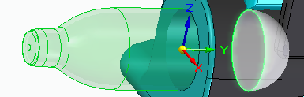
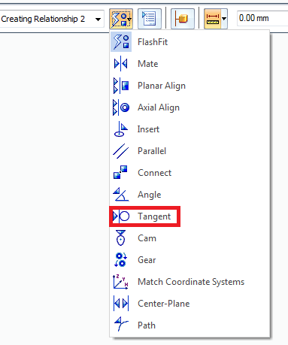

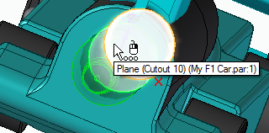
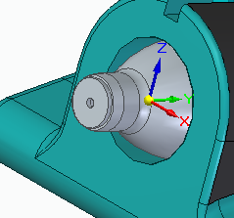

- Click and drag the eye screw from the part library.
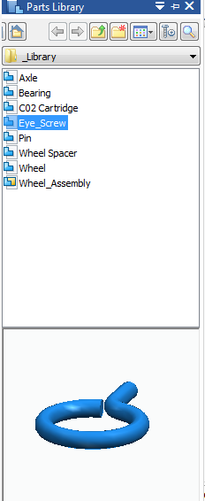
  - For first relationship, select the mate relationship from the dropdown menu.
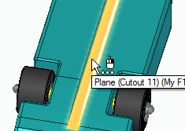
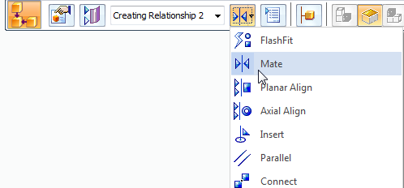
  - Mate flat face of the eye screw with the face of the slot.

  - For second relationship, select the center plane relationship from the drop down menu.
    - Set the option to Single.
  - Select the centerline of the eye screw and two lateral faces of the slots to align.
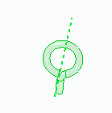
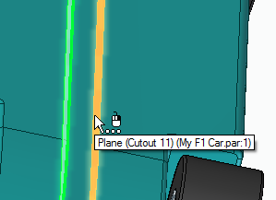
  - Press esc to exit.

- Click on the eye screw to select it.
  - Orient the model by clicking the front side of the cube in lower right side of the screen.

- Use the steering wheel to bury to the screw into the car body.
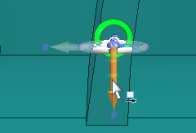
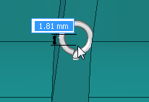
  - Lower the screw into the body around 1.8 mm.
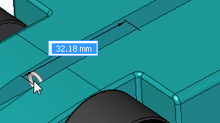
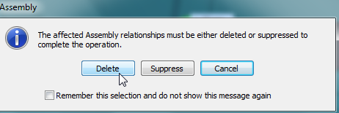
  - Click on the delete button in dialogue box which appears.
- Using the steering wheel to move the eye screw
behind the rear axle.

- Select the Move -Copy option to create a copy and drag the eye screw towards the front of the car.
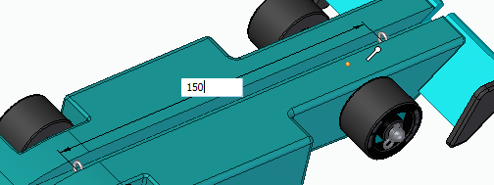
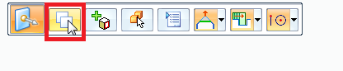
  - Around 150 mm from the back eye screw
- This completes the car assembly.
