F1 in Schools Tutorial Script - 05 Style with Sync

- Start by opening the previously made F1 Body design assembly. (My_F1_Car_Assembly.asm)

- To enter the face priority selection mode while working in the assembly:
  - Press and hold the Ctrl key, then press the spacebar to enter editing mode.

- Select the lateral face at the front of the car as indicated in the picture.
  - Click and drag the steering wheel to the vertical edge to pivot the face.
  - Click on the torus of the steering wheel to initiate rotation.
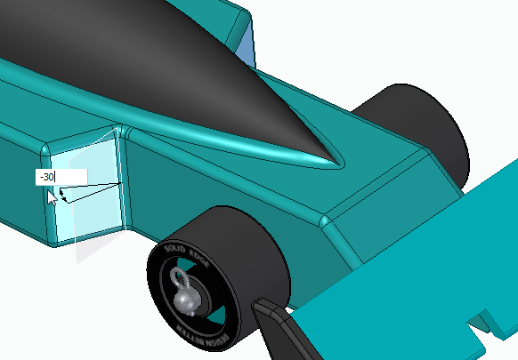
  - Rotate the face -30 degrees.
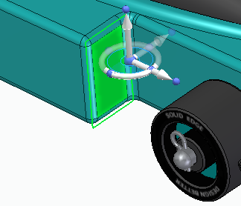
- Relocate the steering wheel to the top edge of the same face.
  - Click the middle of the steering wheel and drag to desired location.
  - Rotate the face -25 degrees.
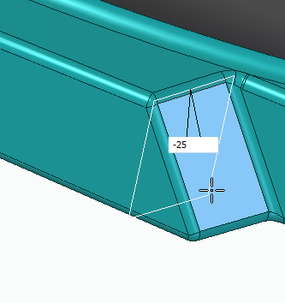
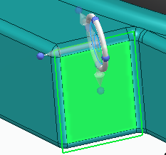
- Notice the changes made to one side is applied to the other side automatically.
- Move the steering wheel to lateral edge of the side of the car.
  - Click and drag the arrow along the same axis to shorten the length as shown in the picture.
  - Change the length to 15mm.
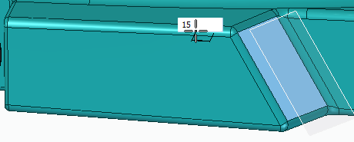
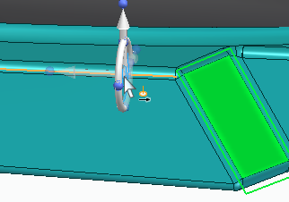
- Click on the back face of the same structure.
  - Click and drag the steering wheel to the vertical edge.
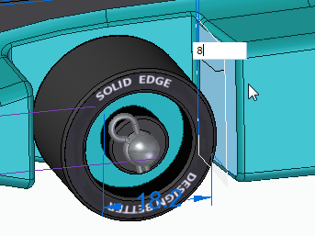
  - Rotate the face 8 degrees to add more clearance for the wheel.
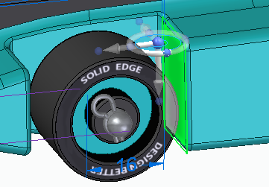
- Click and drag the steering wheel to the top edge of the face.
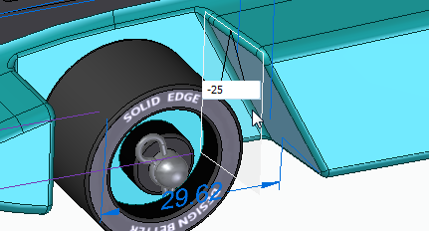
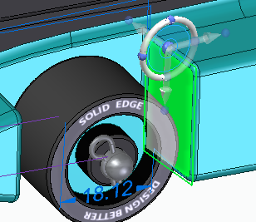
  - Rotate the face 25 degrees.

- Select the face behind the rear wheel.
  - Click and drag the steering wheel to the vertical edge of the face.
  - Rotate the face -8 degrees.
- Move the steering wheel to the bottom edge of the face.
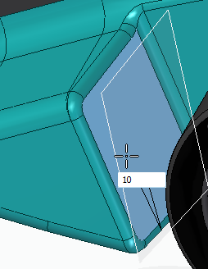
  - Rotate the face 10 degrees.
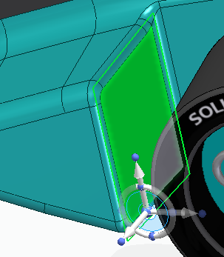
- Select lateral face at the end of the car body.
  - Click and drag the steering wheel to the vertical edge of the face.
  - Rotate the face -30 degrees.
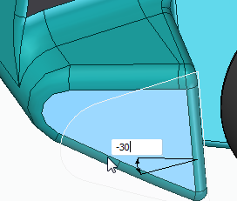
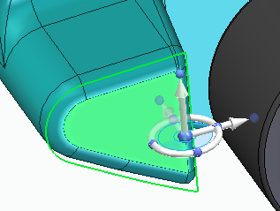
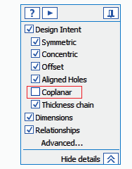
  - Remember to uncheck coplanar option from the design intent box.
- Orient the model to a right side view by clicking the view box at the bottom right corner of the screen.

- Click and drag a box around the front of the car to select the front include the front wing.
  - Move the Steering wheel above the car.
  - Click the arrow on the steering wheel to shorten the length of the car.
  - Shorten the length to 12mm.
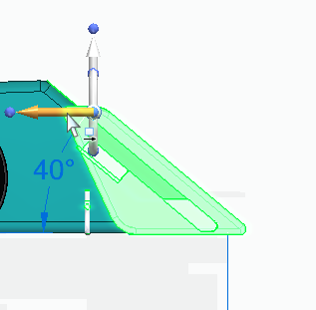
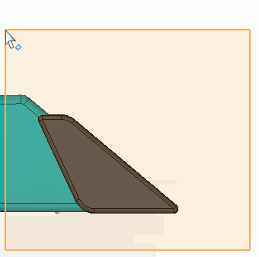
- Select the complete front of the car including the front wheel.
  - Click and drag a box around the desired features to select.
  - Shorten the length additional 12mm.
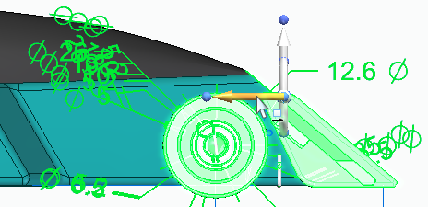

- You have now completed the F1 Car assembly.
  - KeyShot can be used to generate photo-realistic renderings of your car.

